

***A mini project report on***

**Bitcoin Price Prediction Using LSTM and GRU**

*Submitted in partial fulfilment of the requirements for the machine learning laboratory during 6th semester of*

**Bachelor of Technology**

**in**

**Computer Science & Engineering**

***Submitted by :***

***01FB16ECS444 Vikram***

***01FB16ECS447 Vinay Raj***

***01FB16ECS453 Vishwas M Joshi***

***Under the guidance of***

***Jyothi R***

**Internal Guide**

**Asst Prof**

**January – May 2018**

**DEPARTMENT OF COMPUTER SCIENCE AND ENGINEERING**

FACULTY OF ENGINEERING

**PES UNIVERSITY**

**(Established under Karnataka Act No. 16 of 2013)**

**100ft Ring Road, Bengaluru – 560 085, Karnataka, India**



**PES UNIVERSITY**

(Established under Karnataka Act No. 16 of 2013)

100ft Ring Road, Bengaluru – 560 085, Karnataka, India

**FACULTY OF ENGINEERING**

**CERTIFICATE**

*This is to certify that themini project entitled*

**Bitcoin Price Prediction Using LSTM and GRU**

*is a bonafide work carried out by*

***01FB16ECS444 Vikram***

***01FB16ECS447 Vinay Raj***

***01FB16ECS453 Vishwas M Joshi***

In partial fulfilment for the machine learning laboratory during sixth semester in tthe Program of Study

Bachelor of Technology in Computer Science and Engineering under rules and regulations of PES

University, Bengaluru during the period Jan. 2019 – May. 2019.

Signature Signature

<Guide Name> Dr. Shylaja S S

< Designation> Chairperson

**Name of the Examiners Signature with Date**

1. **_________________**
2. **__________________**

**TABLE**  **OF**  **CONTENTS**

**1.0**   **Introduction** **...................................................................................................**

**1.1**   **Overview** **........................................................................................................**

**1.2**   **Scope** **.............................................................................................................**

**1.3**   **Objective** **........................................................................................................**

**2.0 Literature Survey.....................................................................................** **2**

**3.0**   **Methodology** **............................................................................................** **2**

**3.1**   **Proposed**  **Approach** **.....................................................................................** **2**

**4.0**   **Environment**  **Requirements** **....................................................................** **3**

4.1   **Hardware**  **Requirements** **...............................................................................** **3**

4.2   **Software**  **Requirements** **................................................................................** **3**

4.3   **Data**  **Requirements** **......................................................................................** **3**

**5.0**   **Proposed**  **Approach** **................................................................................** **3**

**6.0**   **Results** **.....................................................................................................** **4**

**7.0**   **Conclusions** **.............................................................................................** **4**

**8.0**   **Future**  **Work** **...........................................................................................** **4**

**9.0**   **References** **.............................................................................................** **5**

**1.0   Introduction**

Cryptocurrency has become increasingly popular over the few years. Bitcoin is one of the most popular and widely known cryptocurrency. It is mainly designed to remove the need of any third party entities or financial institutions and thereby eliminate the possibility of fraud during the transactions. One significant and unique characteristic of Bitcoin is the multi-version concurrency control that allows safe concurrent transactions without any significant delay. Cryptocurrency has a total market cap of around $600 billion USD by the end of December 2017 with Bitcoin having a market cap of around $300 billion USD share in the cryptocurrency market.

**1.1   Overview**

Not only the investors but also brokers and private investors are finding

cryptocurrency as an investment tool. In this regard, it is very much necessary to predict the future values of cryptocurrency so as to take correct trading decisions. In the past years, traditional statistical methods such as linear regression were popular. However, due to uncertainty in the trends of financial markets, computing techniques such as neural networks have become quite popular. Artificial Neural networks can adjust by itself based on the information given to it. They have the capability to capture the non-linear trends of the financial markets.

**1.2   Scope**

Bitcoin has hit three speed bumps in its market perception and evolution. None of these present a serious impediment to long-term adoption and growth:

* First, it was the perception that cryptocurrency was a tool of crime, vice or tax evasion. This proved to be a false perception.
* Then, it was the mismanagement and/or insolvency of exchanges and hosted wallet services. One might expect such events before the emergence of standards & practices and trusted accreditation bureaus. In any event, they are moot to early adopters that understand the tools.
* And now there exists a ‘forking crisis’ which is a result of a reduced mining reward, increased computational complexity and differences of opinion about solving transaction problems that are not really so hard to resolve.

**1.3   Objective**

The goal or objective of this project is to predict the highest and closing price of Bitcoin on a given day based on the Bitcoin data of several preceding quarters. It is technically challenging to predict the accurate price, mainly due to lack of seasonality and highly volatile nature of the cryptocurrency market. This is basically a time series prediction problem. Artificial neural network (ANNs) models of time series is used to perform the prediction task, mainly due to the ability of ANNs to deal with non-linearities in the data such as lack of seasonality. Temporal neural network 2 architectures such as recurrent neural networks (RNN) is used for prediction task in this study. The model is trained and tested on our Bitcoin data set

**2.0   Literature   Survey**

Various approaches have been used in the past to carry out the price prediction task. There are mainly two sets of literature that are highly relevant to this work. One is financial data analysis; the other, time series data analysis.

1) Financial Data Analysis.

Several approaches are described in the literature including, one called technical analysis also known as “charting” that forecasts future prices (Lo et al., 2000). According to it, stock market prices do not follow random walks, that is – the price movements follow a set of patterns. These price movements can be used to predict the future price (Lo & MacKinlay, 1988, 1999). There exist some other empirically designed patterns such as heads-and-shoulders, double-top-andbottom that can be used to predict future prices. We refer the interested reader to the work of Lo et al. (2000). In this paper, authors have used kernel based regression techniques to find out the patterns in historical data, that is – price is predicted based on past data. This work (Lo et al., 2000) is theoretically close to the current project work. However, it does not employ the same strategies followed in the current project.

Also data set is from Kaggle.

<https://docs.coinranking.com/public>

2) Time Series Data Analysis

In the context of future price predictions, classical methods are quite popular. Autoregressive integrated moving average (ARIMA) models are a popular choice for forecasting over a short term. It works very well when the data exhibits consistent or stable pattern over time with least possible 4 outliers. The ARIMA methodology works well only when the data exhibits “stationarity”, which means that the series remains almost constant. But this is not always possible in the real time scenario, where the data fluctuates drastically, and it is highly volatile. Ediger and Akar used the seasonal ARIMA model to estimate the future fuel energy demand in Turkey over certain years. However, the similar scenario is not guaranteed to work for unseasonal or non-linear data. To solve the real time prediction problems, artificial neural networks are very much useful to increase the speed of computation due to its ability to handle nonlinearities in the data. Examples of nonlinear data include psychological data (Scheier & Tschacher, 1996).

**3.0**   **Methodology**

**3.1**   **Proposed**  **Approach**

**The technical details and approaches used for prediction of the Bitcoin closing and the highest price are discussed in this section.**

**1) Long Short Term Memory(LSTM) approach**

LSTMs are an extension of the classic recurrent networks, which address the vanishing gradient problem (the gradient tends to zero as the error propagates through many layers recursively). The long-short term memory cell uses an input, a forget and an output gate. Those gates help the network learns what to save, what to forget, what to remember, what to pay attention and what to output. Pretty neat right? Remember that a gate is nothing more than a simple multilayer perceptron, but a smart combination 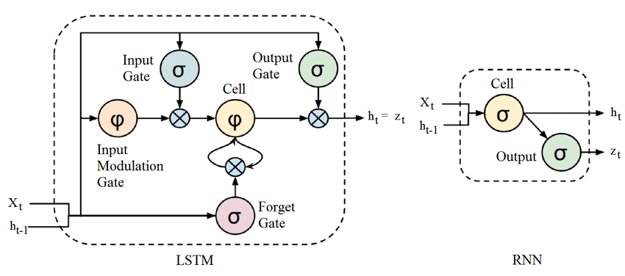

Each LSTM cell has its cell state (c) and has the ability to add or remove information to it.

The forget gate decides what to remove from the cell state(f), while the input gate (i) decides which values it will update.

The tanh layer creates a vector of new candidate values (c_hat), that could be added to the state.

The input gate and the new candidate states are combined to update the cell state.

Finally, it has to decide what to output (h). That is the responsibility of the output gate(o), which in fact filters the cell state from the unnecessary info. The output will be the feedback for the next round of training.

2) **GRU**

GRUs are improved version of standard recurrent neural network. But what makes them so special and effective?

To solve the vanishing gradient problem of a standard RNN, GRU uses, so called, **update gate and reset gate**. Basically, these are two vectors which decide what information should be passed to the output. The special thing about them is that they can be trained to keep information from long ago, without washing it through time or remove information which is irrelevant to the prediction.To explain the mathematics behind that process we will examine a single unit from the following recurrent neural network:

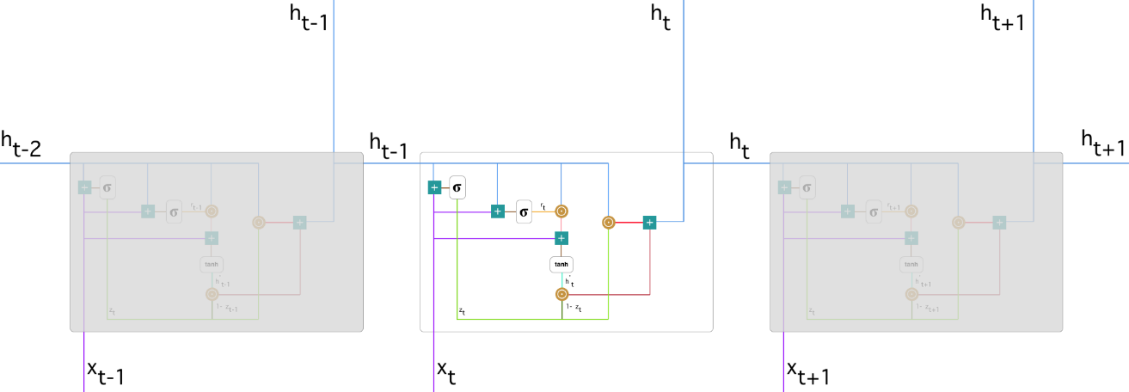

**4.0**   **Environment**  **Requirements** **.**

**4.1   Hardware   Requirements**

1. 2GB RAM
2. Windows/Linux/Mac0S
3. I5 Intel Processor

4.2   **Software**  **Requirements**

1. Python
2. Anconda Jupyternotebook
3. 3.Keras

**4.3   Data   Requirements**

We collected the dataset from coinRanking’s.com API which basically provides up to date coin prices that can be used in an platforms.

**\*) Data set name :-** Kaggle Dataset for Bitcoin

**\*) Data set information :** Timestamp,Open,High,Low,Close,Volume_(BTC),Volume_(Currency),Weighted_Price

**Data cleaning**

All the NaN values are replaced by previous days bitcoin price.

**5.0**   **Proposed**  **Approach**

The lstm and GRU is the proposed approach in this COIN PRICE prediction model.The

Lstm is the better current approach than other approaches because its accuracy

score is more than other approaches in price prediction model.and this is the

best approach for neural neworks problems.

**6.0**   **Results.**

**LSTM Result :**

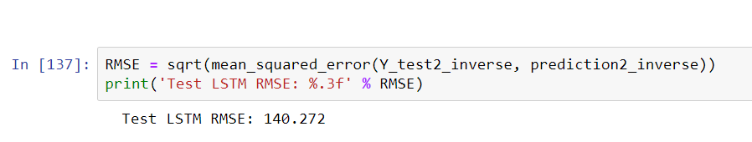

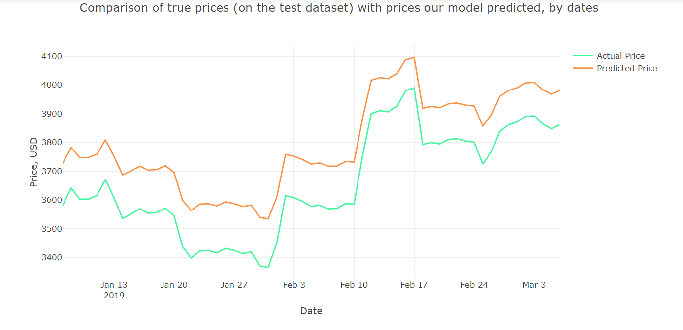

GRU Results :

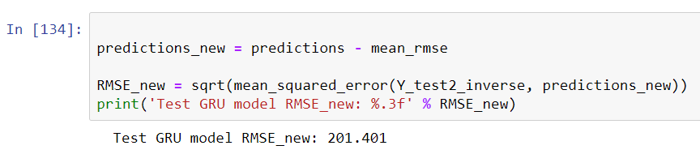

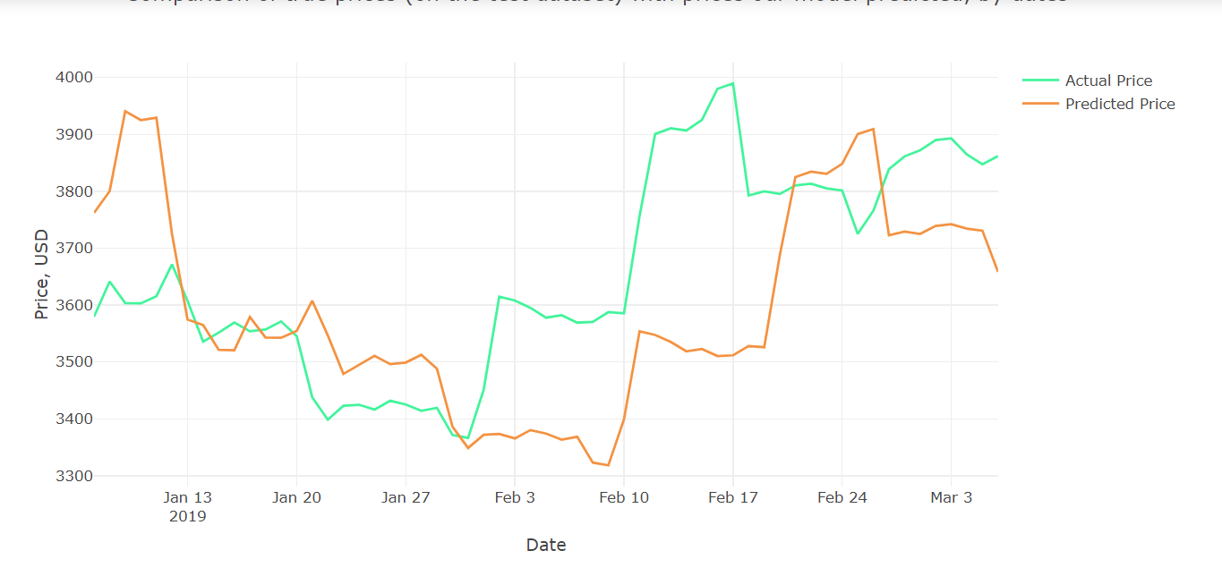

**7.0**   **Conclusions**

This work presents an application of artificial neural networks for making one day ahead prediction of highest and closing price of cryptocurrency Bitcoin. Two temporal neural network architectures have been considered: long short term memory and a recurrent neural network (RNN). Also, comparisons between lstm and RNN have been presented.

**8.0**   **Future**  **Work.**

Current work focuses on one-day ahead and partly on three-day ahead prediction (2016-17 data set) of Bitcoin price. However, we can follow a similar procedure to perform multi-step ahead prediction of Bitcoin price thereby increasing the scope of experiments. In addition to cryptocurrency Bitcoin, there are other cryptocurrencies such as Ethereum, Litecoin, Ripple, etc. that gained attention in the trading markets. Analysis on these cryptocurrencies can help investors decide which one to buy or sell so as to end up with profitable trades. Also, I have plans on using the GPU based accelerator that can significantly reduce the training time of the models. The scope of this project can be extended to use some deep learning techniques..

**9.0**   **References.**

1.Medium

2.Python

3.Kaggle